Testing Project for www.fasiondays.ro

Purpose of Testing

Let's make sure the login section works as specified and provides a safe and pleasant user experience.

Application to test: www.fashiondays.ro
Tools used: Jira, Zephir Squad

Features to Test
• The login form
• Validation of input data
• Error messages
• Password recovery
• Redirection after successful login
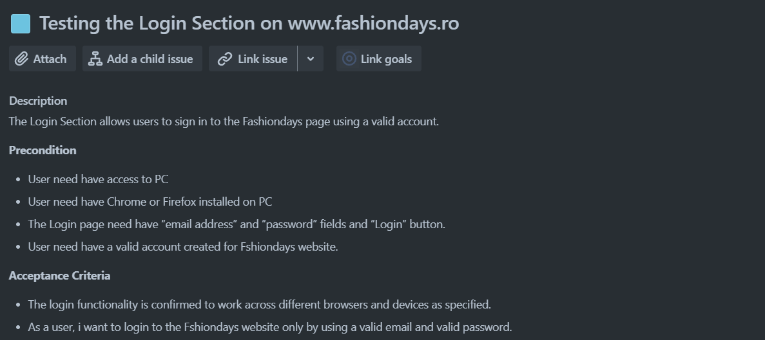
The test scenarios attached here were created in Jira and describe a series of functional specifications of the "Entry account" module for which the final project is built.

Release
Here you can find the release that was created for this project:
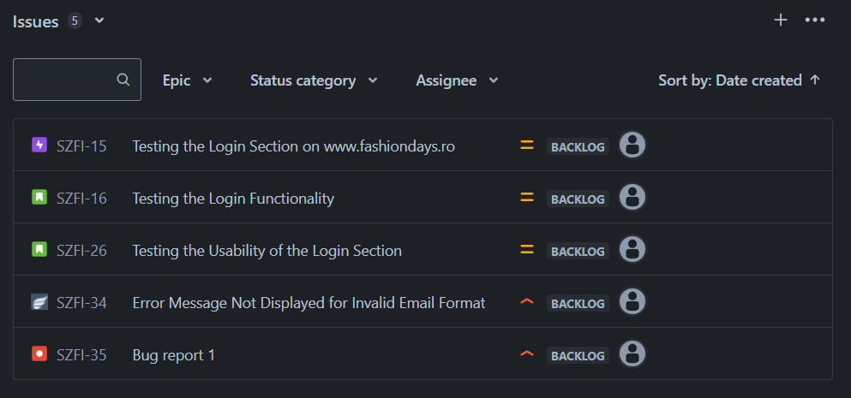

The testing process
The testing process was conducted based on the standard testing process as described below.
Test planning
The test plan is designed to describe all the details of the testing for the Fashiondays e-commerce application login module.
The plan identifies the items to be tested, the features to be tested, the types of testing to be performed, the personnel responsible for testing, the resources and schedule required to complete the testing, and the project risks associated with the plan.
The roles assigned to the project and the assigned persons
Project manager: Razvan Iorga
Product owner: Luiza Oprea
Software developer: Mihai Alexe
QA Engineer: Florin Zugrava
Entry criteria defined
• All functional and non-functional requirements for the logging section must be documented and approved.
• The test environment (servers, databases, etc.) must be properly configured and available.
• The test team must be available and ready to start testing.
• A stable and complete version of the login section must be available for testing.
• The test plan must be complete and approved, including the test schedule and allocated resources.
• The error tracking system must be configured to report and monitor defects.
Defined exit criteria
• At least 90% of executed test cases are passed successfully.
• All identified critical and major defects are resolved.
• A final test report is prepared and approved by relevant stakeholders, including a summary of test activities, results, defects and recommendations.
• Ensuring that each requirement has an associated test case and that all requirements are verified (according to the traceability matrix).
• Performance tests should show that the login section works within acceptable time limits (eg response time under 3 seconds).

Tests to be applied
Functional Tests
Authentication Tests with Valid Data
• Verification of login with a valid email and password.
• Testing authentication with different accounts (eg regular user accounts, administrator accounts).
Error Handling Tests
• Check the wrong password error message.
• Checking the error message for non-existent e-mail.
• Error message check for blank fields.
Password Reset Tests
• Verify password reset functionality via email.
• Check success and error messages for the password reset process.

User Interface (UI) Testing
Checking Visible and Functional Elements
• Checking the visibility and functionality of the login button.
• Checking the presence and functionality of the "Forgot Password" and "Create Account" links.
Tests I don't intend to do
I will not cover in this project any technique related to white box testing.
I will not perform the performance and security tests.
Also, I will not perform compatibility tests on multiple browsers and different operating systems and devices in this project.

Project risks
1. Functional Risks
Nonconformity of Functionality
• Risk: Critical login functionality does not work as specified (eg failed authentication with valid data).

2. Usability Risks
Navigation problems
• Risk: Tab navigation does not work properly, affecting users who use the keyboard for navigation.
Product risks
1. Functional Risks
Non-Operative Logging Features
• Risk: Users cannot log in due to errors in the login functionality.
2. Inappropriate Error Messages
• Risk: Error messages displayed are not clear or do not provide enough information for users

3. User Experience (UX) Risks
Difficult Navigation
• Risk: Users have difficulty navigating the login section, affecting the overall experience.

Test Analysis
The testing process will be executed based on the application requirements.
The following test conditions were found:
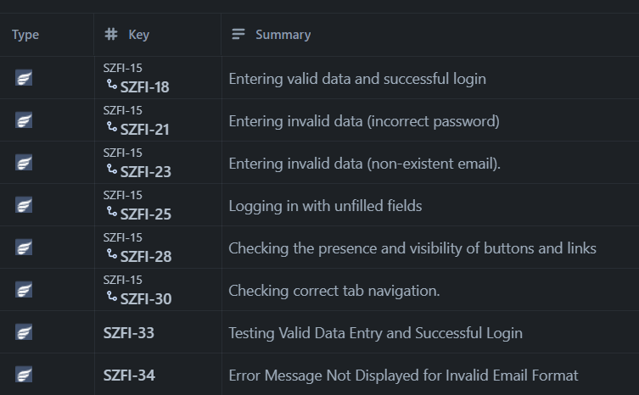

Test Design
Functional test cases were created in Zephyr Squad based on the analysis of the specifications. The test cases can be accessed on link https://github.com/Florin0388/Repo2/blob/main/Jira_Testcase.pdf or see here:
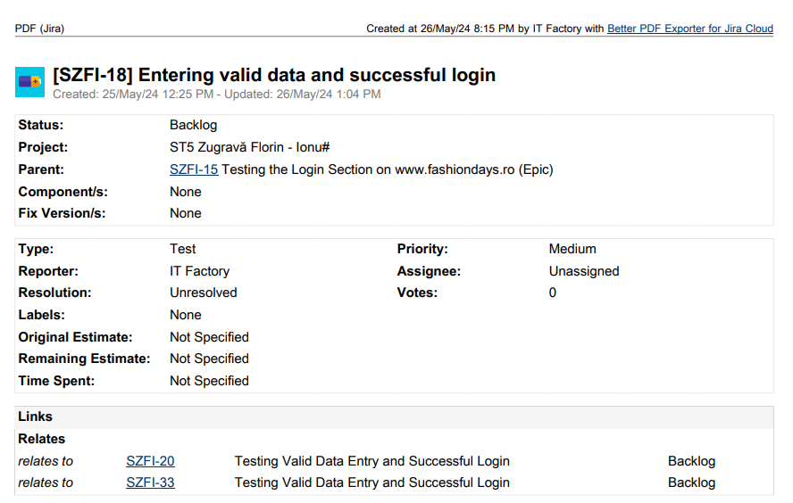
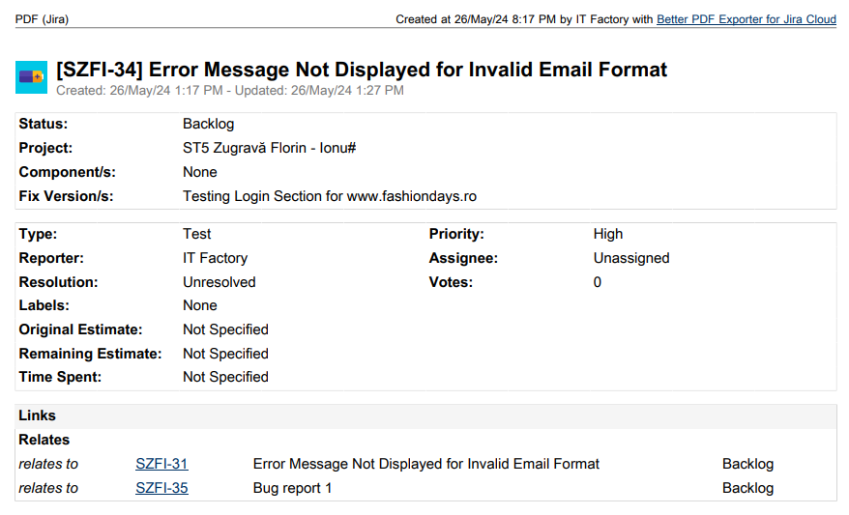

Test Execution
Test cases are executed on the created test Cycle summary with name:
Test Login Section fashiondays
Bug have been created based on the failed tests. The complete bug reports can be found here on link https://github.com/Florin0388/Repo2/blob/main/Jira_Bug.pdf or here :

Steps to Reproduce:
Navigate to the www.fashiondays.ro login page.
Enter an invalid email format (e.g., "invalid-email") in the email field.
Enter a valid password in the password field.
Click the "Log in" button.
Expected Result:
An error message should be displayed, indicating that the email format is invalid.
Actual Result:
No error message is displayed, and the user remains on the login page with no feedback.

The following is a summary of the bugs that have been found:
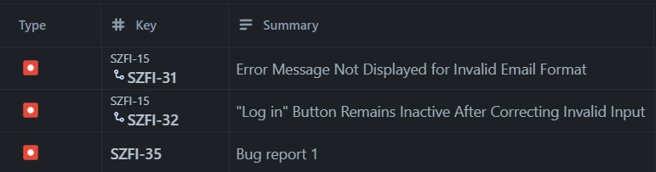
- SZFI - 31 → Priority High, Severity Medium
- SZFI – 32 → Priority High, Severity Medium
Full regression testing is needed on the impacted areas after the bugs are fixed and retesting will be done for every functionality that was previously failed.

Test Completion As the Exit criteria were met and satisfied as mentioned in the appropriate section, this feature is suggested to ‘Go Live’ by the Testing team
The traceability matrix was generated and can be see here:
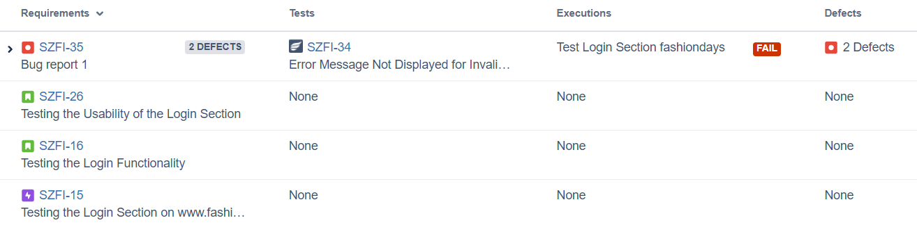

Test execution chart was generated and can be found below or at this link https://github.com/Florin0388/Repo2/blob/main/Jira_MatriceTrasabilitate.xlsx
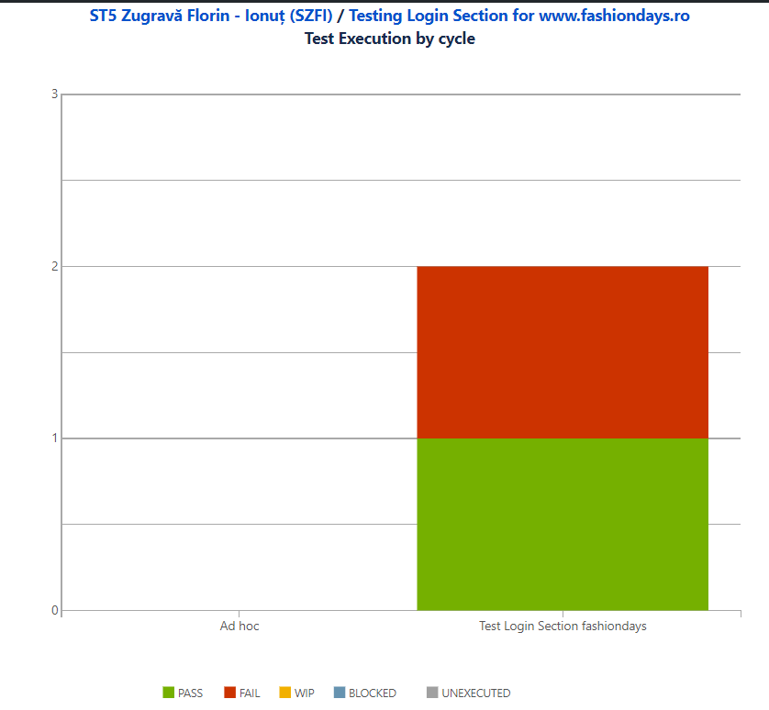
The final report shows that a number 1 tests have failed of a total of 2 tests.
A number of 2 total bugs were found, from which the priority is: 2 are high .

General Testing Conclusion
Overview:
During the testing of the login functionality on www.fashiondays.ro, a comprehensive set of tests were created and executed to ensure the reliability and usability of the login process.
Test Creation and Execution:
- Total Test Cases Created: 10
- Total Test Cases Executed: 10
- Test Coverage: Approximately 90% of the requirements within scope were covered.
Functionalities Covered:
- Valid login attempts
- Invalid login attempts with incorrect password
- Invalid login attempts with non-existent email
- Login attempts with unfilled fields
- Usability aspects including button visibility and tab navigation
- Cross-browser and cross-device compatibility
- Security checks for login credentials
- Performance under normal and peak loads
- Accessibility compliance
Untested Functionalities:
- Social media login options (e.g., logging in with Facebook or Google)
- Multi-factor authentication (MFA) if applicable
Bug Impact Analysis:
- Total Bugs Identified: 2
- Severity and Priority:
  - SZFI - 31: Medium severity, High priority
  - SZFI - 32: Medium severity, High priority
- Impact on Production Launch:
  - SZFI - 32 significantly impacts user experience and should be fixed before the product is launched to production.
  - SZFI - 31, while less critical, still affects the usability and should ideally be resolved before launch, but it could be fixed in a subsequent update if necessary.
Identified Product Risks:
- Risk: Users unable to reattempt login after correcting errors without refreshing the page (SZFI - 32).
  - Mitigation: Ensure that the login button is re-enabled after correcting inputs.
- Risk: Lack of immediate feedback for invalid email formats (SZFI - 31).
  - Mitigation: Implement validation and error messaging for email formats on the login page.
Recommendations:
- Bug Fixes Prior to Launch:
  - Fix SZFI - 32 to enable users to reattempt login without refreshing the page.
  - Address SZFI - 31 to improve user feedback and experience.
- Extended Testing:
  - Perform additional tests on social media login options and multi-factor authentication if applicable.
- Post-Launch Monitoring:
  - Continuously monitor user feedback and performance metrics post-launch to identify and address any emerging issues.
- User Training and Documentation:
  - Provide clear documentation and user guides to help users navigate the login process effectively.
- Future Enhancements:
  - Plan for iterative improvements based on user feedback and emerging requirements.
With these considerations addressed, the login functionality on www.fashiondays.ro can be confidently launched, ensuring a smooth and secure user experience.

